
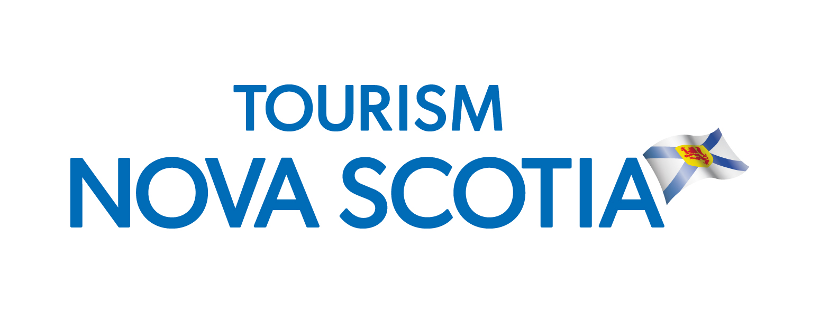

2017 AAA Travel Marketplace
March 3-5, 2017 ~ Foxborough, MA
PARTNERSHIP OPPORTUNITY
http://www.southernnewengland.aaa.com/sne/marketplace/

Tourism Nova Scotia has purchased equivalent of 5 booth spaces (plus electrical / internet / video promotion) at this well attended marketplace to showcase the vacation products and packages that Nova Scotia has to offer in an effort to attract first-time and repeat visitors in the New England area.

About the Show
The AAA Travel Marketplace is one of New England’s largest travel shows which attracts close to 18,000 members. AAA actively promotes the marketplace to its 2.7 million members through an aggressive marketing program throughout the southern New England area. A limited amount of space is available for industry operators. You must be AAA preferred supplier or a DMO in order to participate at the show.

Show Details
Event Dates: March 3-5, 2017
Location: Gillette Stadium, Foxborough, MA
Hours: Friday March 3: 9 am – 12 pm exhibitor setup
2 pm – 8 pm consumer hours
Saturday, March 4: 10 am – 7 pm consumer hours
Sunday, March 5: 10 am – 5 pm consumer hours
5 pm – 8 pm take down all exhibits
Accommodations: AAA has secured room blocks at various local hotels for exhibitors at preferred rates (room release date is January 31, 2017). Requests for access to these blocks are made via AAA:
https://www.southernnewengland.aaa.com/marketplace/vendor/hotel-reservation-request-form

Participation
$1,200 CAD per partner organization:
- Small table / counter within the Nova Scotia section. (Table top displays only - no pop-up booths or pull-up banners)
- Shipping of materials to/from Distribution Centre

Travel costs and any other arrangements not listed above are the responsibility of each individual participant. Registration deadline is Friday January 6, 2017 (please note space is limited).

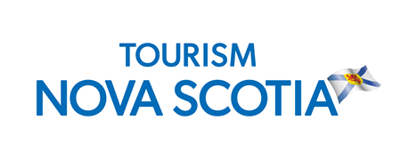
2017 AAA Travel Marketplace
March 3-5, 2017
Foxborough, MA

Business Name:

Delegate:
Mailing Address:
Phone:

Fax:

Email:

Website:

AAA Preferred Supplier? | Yes | No
Additional Delegates?
(charges may apply)

Registration deadline is Friday January 6, 2017 (space is limited). Invoices will be issued by Tourism Nova Scotia with payment due by Friday February 3, 2017.

Please send your registration to
Pam Wamback
pamela.wamback@novascotia.ca

